DICOM splitting into 2 Nifti files

Project – Loki 1
Subject – 811
Ses – 06, 02
Run – 05 ( for both)

Reason for the split -
The acquisition number (as seen in the json files for each split nifti) switched from “1” to “650” . [Only checked for ses-06]

Things attempted -

1. Re-run dcmniix gear in flywheel.
- No difference, even after changing gear config.

2. Download the 2 nifti files and concatinate using “fslmerge” command.
- Got 1 nifti image but the order between split 1 and 2 not clear.
- Plotted time-series using krista’s script to look for continuity.

Example -

Split 1 + Split 2
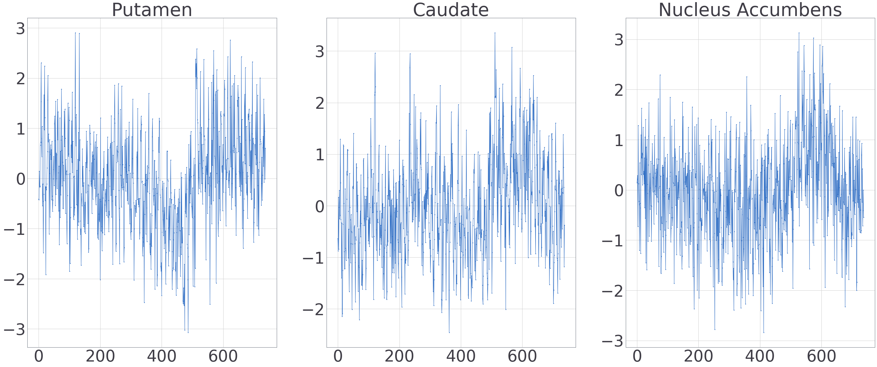

Split 2 + Split 1

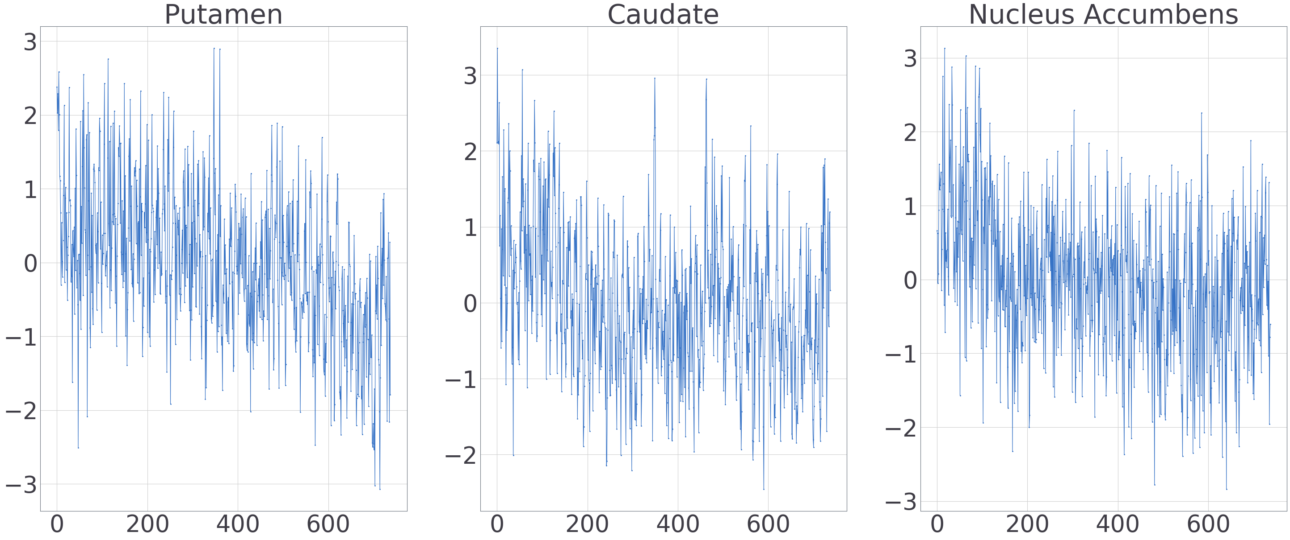
Second image (ie. split 2+ split 1) seems better but can’t be sure. Maybe plot DICOM in the future if needed (As per Javi’s suggestion).

3. Convert Dicom to Nifti locally using dcmniix. [This worked!]
- Enable always merge option (bottom left in the image below)
- Output 1 nifti file with comparable file size to all other runs. Time series also verified.
